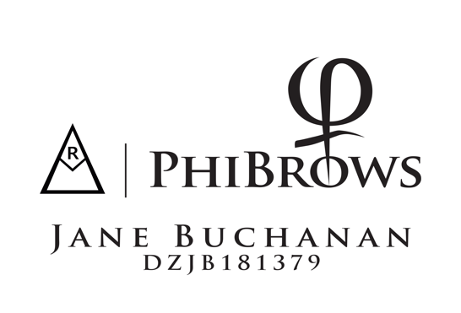
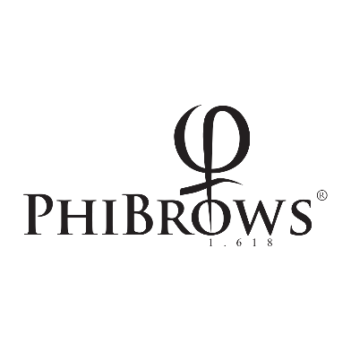

CONSENT FOR EYEBROW DRAWING USING PHIBROWS MICROBLADING TECHNIQUE

PHIBROWS ROYAL ARTIST | Name
Aesthetics By Jane | Address
18 Drumcill Road
Lisburn
Co Antrim
BT282TG | Date of Birth
 | email address
 | Mobile Number

AESTHETICS BY JANE is obligated to perform the treatment in strict compliance with all hygiene and health protection measures

I can not work over previous SPMU unless it has fully faded or has been removed. Microblading alone will not cover the old work. If you have had previous SPMU done with another artist please inform me at the first point of contact and forward clear photos. Failure to do so may result in the treatment not being carried out on the day if the skin is not suitable.

HEALTH CONDITION QUESTIONNAIRE
In order to perform the eyebrow drawing treatment in a safe manner, please answer the following health question truthfully. Please let me know in advance if there is anything relevant.

Do you suffer from the following diseases or are you taking any of these medications?
Diabetes mellitus (diabetes) Type 1 or Type 2(this requires GP consent) | YES | NO
Hepatitis A, B, C, D, E, F | YES | NO
HIV + | YES | NO
Skin diseases | YES | NO
Eczema | YES | NO
Autoimmune diseases | YES | NO
Are you prone to herpes? (Cold sores) ***cannot treat if a cold sore is active) *** | YES | NO
Infectious diseases / high fever | YES | NO
Haemophilia (blood does not clot easily) | YES | NO
Are you taking ibuprofen (avoid if possible 24hrs prior to treatment) | YES | NO
Epilepsy | YES | NO
Cardiovascular problems | YES | NO
Are you taking medication for blood thinning (anticoagulants)? | YES | NO
Are you pregnant or breastfeeding? | YES | NO
Are you taking any medications on daily basis? | YES | NO
Are you taking Roaccutane? Treatment cannot be performed until 6months after the course finishes | YES | NO
Do you have a pacemaker? (GP consent required) | YES | NO
Do you have problems with healing of wounds? | YES | NO
Have you consumed drugs or alcohol in the last 24 hours? | YES | NO
Did you in the last 14 days undergo surgery,  Were you exposed to radiation or had any other medical interventions? | YES | NO
Very oily skin | YES | NO
Allergies | YES | NO
Retinol, Glycolic, AHA’s, facial peels (discontinue use 4 weeks prior to treatment) (do not use again until 4 weeks after treatment) | YES | NO
Botox or Dermal fillers (3 weeks either side of treatment) | YES | NO
Laser or light therapy (Do not use 2 weeks prior to and 4 weeks after treatment)
This information is confidential and it shall also be handled in that way

AESTHETICS BY JANE assumes no liability in case of giving false information.

3. CONTRACTUAL OBLIGATIONS
I agree on photo taking and using the photos for advertising purposes. | YES | NO

4. WARRANTY
Aesthetics By Jane accepts liability in compliance with the legal measures and regulations in the case of negligence or carelessness or intentionally or negligently caused injuries or threat to life, body and health. Aesthetics By Jane is liable for violations of the obligations specified under the Agreement.

5. EXPLANATION
The client is informed in detail by Aeathetics By Jane about specific risks of eyebrow drawing treatment using microblading technique.

The following risks are specifically explained to the client:

During the treatment, despite the artist’s expertise and all the precautionary measures, a skin injury is possible. Despite the application of the most advanced and the top quality pigments, allergic reaction is possible but rare. The client is informed about this and he/she assumes liability. During and after the treatment temporary swelling, redness and/or itching may occur. Experience tells us that these symptoms are temporary and subside after 24-48 hours.

Depending on the skin structure after the first treatment small scabs with a loss of drawn hairs may occur and colour intensity may change. In the first seven days eyebrows are up to 40% darker and 10-15% thicker. Colour i.e. colour reflection depends on the natural skin tone. . The shape is determined according to the natural face proportions and own natural bone structure which makes the shape of your eyebrow unique to you. Symmetry is determined digitally, with closed eyes because of the negative impact of facial expression. In cases where there is asymmetry this will be explained and corrections will be made where possible to do so. Please note that it is not always possible to fully correct asymmetry due to strong facial expression.
. When working I like to save as much of the natural hair as possible to avoid extra maintenance, if a case arises where natural hair must be taken away to achieve a symmetrical shape this will be discussed in full detail and will only be done with the consent of the client. The pigment is absorbed differently due to differences in the skin type and qualiy, , thus there is no warranty for the treatment success or longevity. Depending on the skin structure it should be noted that change in the colour intensity is possible and that one or more additional treatments (a top up) will be required.

The minimum or maximum duration of eyebrow drawing treatment cannot be determined with certainty, nor can the warranty be given on performed treatment. Experience tell us that it lasts for aroumd 1-3 years depending on skin type and other external factors. . The first correction is done around 6-8 weeks after the initial treatment. For oily or highly sensitive skin that has bled excessively it may be necessary to perform additional top up treatments depending on pigment retention.

Additional top ups are not included in the price of the treatment. The cost of additional top up treatments if required is £50 if carried out within 3 months. .

Permanent make-up can lead to skin injury. Therefore, it is important to carefully and gently nurture your skin after the treatment as directed to allow healing without complications. Inadequate care and attention in the initial healing phase after treatment can lead to poor results and Aesthetics by Jane cannot be liable for it.

In the first seven days after treatment the client is required to pay attention to the following:
- Immediately after treatment a skin candy is applied
- 30 mins after treatment clean the brows with the wipe provided and using clean finger gently apply skin candy
- You should then clean the brows with cleaning solution provided or cooled boiled water and reapply cream every 2 -3 hours until you go to bed
- Before going to bed repeat the procedure and apply the Phi Patches. . This is to prevent the scab formation. (Patches are only worn on the first night)
- Day 2 repeat this cleaning procedure morning and night .
- Day 3 to 7 no more cleaning or wiping of the brows, Howe it is important to maintain good skin hygiene. Apply skin candy only morning and night and Do not get your brows wet for 7 days. (Carefully work around them when cleansing skin and applying makeup) For oily skin reduce the application of skin candy as directed.
- Do your best when showering to keep your head tilted back and not to stand with face in the water. You will have the skin candy on the brows which will act as a barrier so if you do get water on them don’t panic. Keep a clean face towel or some kitchen paper to hand when you get out and gently blot them dry.
- For post-treatment care use only Skin candy. It’s a tiny pot but a little goes a long way and it’s also important not to use too much. The size of a grain of rice is enough for both brows. Please do not use any other creams except the ones provided to you in order to prevent possible infections or allergic reactions.

In the first two weeks after the treatment avoid public bathing, sunbathing, tanning salon, sauna, beauty treatments, and intense training accompanied by sweating(5-7 days) contact with the dust (5-7 days.). Aesthetics by Jane is not liable in case of improper post-treatment care. Facial treatments of any kind must be avoided for 4 weeks after your treatment.

TOP UP
Top Up must be completed as part of this overall treatment no sooner than 4 weeks after initial treatment to allow for full skin regeneration and healing. Maximum time allowed for top up is 12 weeks. After 12 weeks treatment is not considered a top up and extra charges may apply due to the possibility of extra work needing done.

Additional Top Ups
Aditional top ups may be required for very oily skin types or sensitive skin that has bled excessively. Additional top ups are charged at £50 within 12 weeks.

6. COMPETENCE
I confirm that I have read and understood the aforementioned information. | YES | NO

Client’s signature | Date
PRINT NAME

The consent is valid without a signature and a stamp.

